LAB # 2
McCulloch-Pitts neuron model

OBJECTIVE

To understand the McCulloch-Pitts neuron model, its working principle, and to implement a simple neural network using this model.

THEORY:

The McCulloch-Pitts neuron model is one of the earliest models of a neuron, proposed by Warren McCulloch and Walter Pitts in 1943. It is a simplified representation of a biological neuron and serves as the foundation for understanding more complex neural network models. This model is significant for its historical contribution to the development of neural networks and artificial intelligence.

Minimum Theoretical Background:

McCulloch-Pitts Neuron:
A McCulloch-Pitts neuron consists of multiple binary inputs, weights, a threshold, and a binary output.

Mathematical Model:
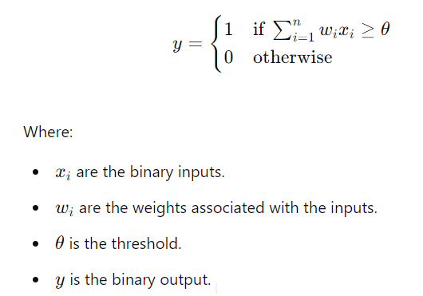

Detailed Steps and Explanation:

- Define weights and threshold for the logical function.
- Calculate the weighted sum of inputs.
- Compare the weighted sum with the threshold to determine the output.

LAB TASKS
- Implement the neuron model to perform the logical AND function.

- Implement the neuron model to perform the logical OR function.

- Implement the neuron model to perform the logical NAND function.

- Implement the neuron model to perform the logical NOR function.

- Implement the neuron model to perform the logical XOR function.

- Implement the neuron model to perform the logical XNOR function.

LAB OUTCOMES

This lab provides a comprehensive understanding of the McCulloch-Pitts neuron model and its application in modeling basic logical functions. By implementing and experimenting with these functions, students will gain insights into the foundational concepts of neural networks.

